# Task 1: High-Level Architecture Design:

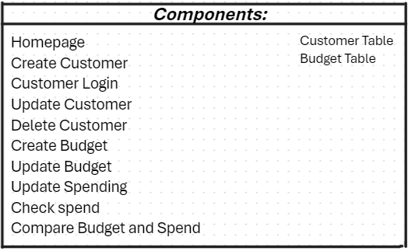***Components:***

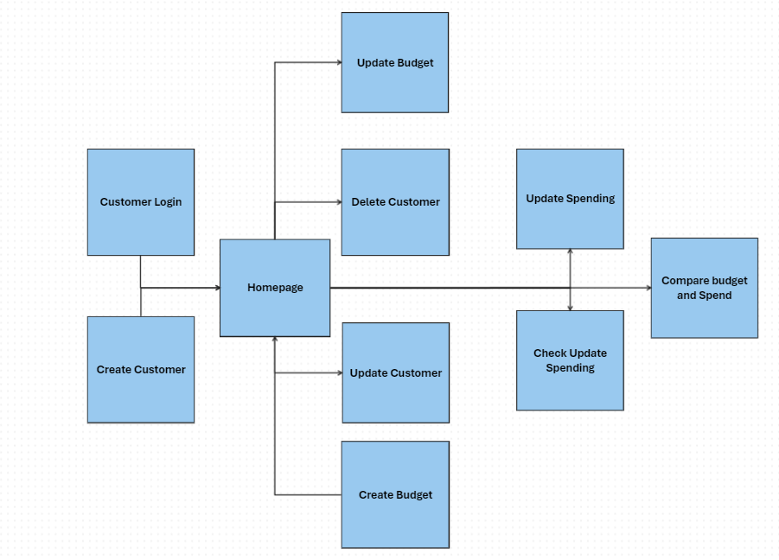

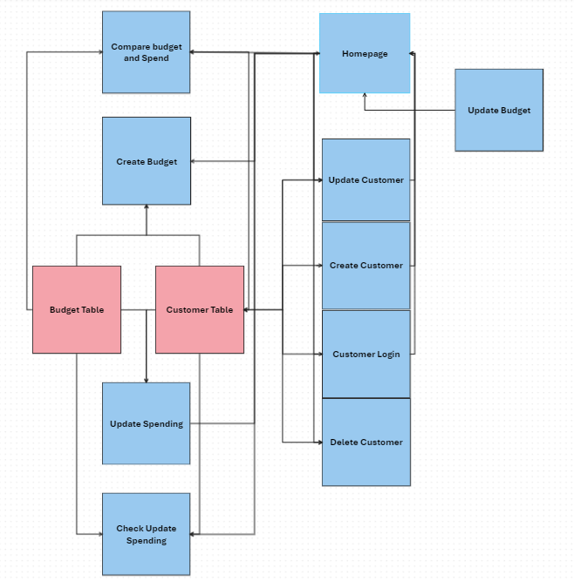

# Task 2: Technology Stack Selection

***Stack Selection:***

We have chosen to use C# as our programming language/s because of previous knowledge of the language

Our choice of frameworks are ap.net because it integrates well with online applications

We have chosen to use Oracle as our database because we have used oracle in the past, it is highly scalable and secure

For monitoring we will be using PRTG because its free, scalable and reliable across all platforms

# Task 3: Dev-ops tool Selection

***Dev-ops tools:***

* PRTG
* Azure Boards
* GitHub
* Azure Repositories
* Whiteboard

# Task 4: Security Considerations

Our project will implement a secure sign-in and login system. To protect emails and passwords, we will use encryption and use techniques to defend against attacks such as SQL injections. SSL will be used to ensure secure transmission, preventing attackers from capturing data like emails and passwords. We will also be blocking out passwords visually as you type so that no one can see your password if they look at your screen.

# Task 5: Data Model Design

***Data Model:***

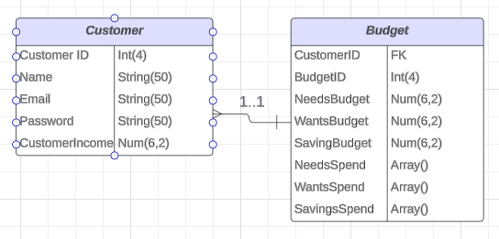<https://lucid.app/lucidchart/0744c6c5-de81-4862-aeb1-e65eaf7a446d/edit?viewport_loc=-1576%2C-488%2C2219%2C1031%2C0_0&invitationId=inv_05b97d2e-ebf2-4d14-89dd-16bf8d0c9cc7>

***Database Schema:***

Budgie Database Schema :

Relation: Customers

Attributes:

customerID: int (4) NOT NULL Unique

name: String (50) NOT NULL

email: String (50) NOT NULL UNIQUE

password: String (20) NOT NULL

customerIncome: double (6,2)

Primary Key: customerID

Relation: Budgets

Attributes:

budgetID: int (4) NOT NULL Unique

customerID: int (4) NOT NULL Unique

needsBudget: double (6,2) NOT NULL

wantsBudget: double (6,2) NOT NULL

savingBudget: double (6,2) NOT NULL

needsSpend: Array ()

wantsSpend: Array ()

savingsSpend: Array ()

Primary Key: budgetID

Foreign Key: CustomerID References Customer

# Task 6: UX Design:

Found inside the repo under the name Budgie ***UI Design.pptx.***

# Task 7: Dependency Management

***Dependency management tool:***

We will use GitHubs depndabot to monitor our dependency’s because it is automatically integrated into GitHub and has been shown to be accurate detecting vulnerabilities and updates

# Task 8: Workflow & Process Diagram:

<https://lucid.app/lucidchart/73911c12-d646-464d-b787-2bb0bb7c036d/edit?viewport_loc=-1839%2C-178%2C6377%2C2763%2C0_0&invitationId=inv_0e5f1659-e745-411d-a7fc-da64b5bd6d54>

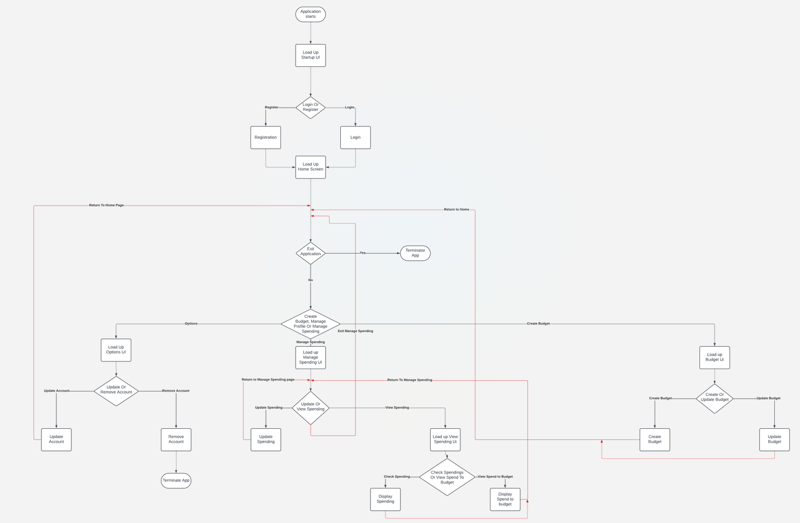

# Task 9: Initial Backlog: